A Celebration of Life
Remembering Ed Winne

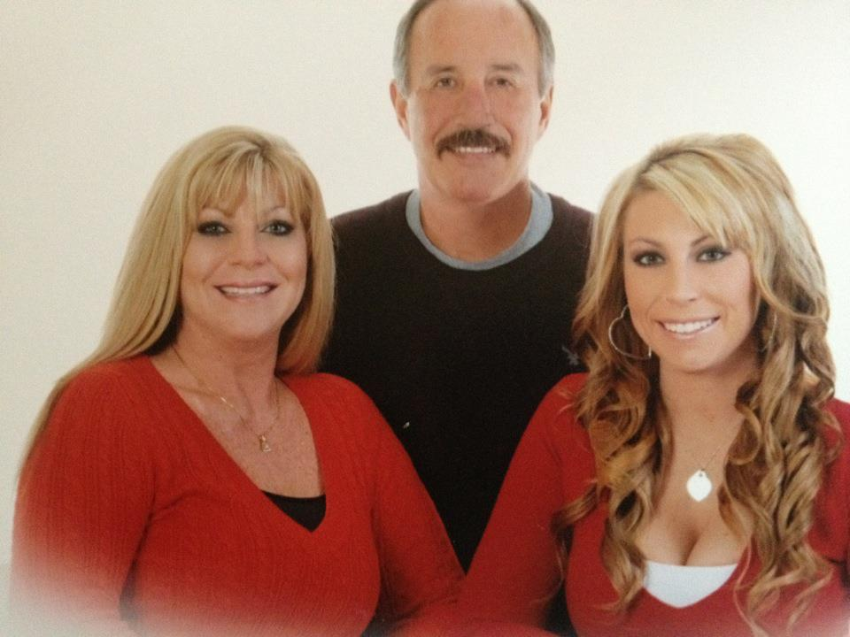

When:
Sunday, June 5, 2016

Where:
We will be meeting at the Freedom High School parking lot (by the football field), and from there we will be traveling as a group to the VFW Hall in Brentwood.
Freedom High School 1050 Neroly Rd. Oakley, CA 94561
VFW Hall 757 First St. Brentwood, CA 94513

The Plan:
We will be meeting at Freedom High School at 11:00 am where we will then travel to the VFW Hall. The Warriors Watch Riders will escort us, so if you have a motorcycle you are welcome to ride along with them. There will be food and refreshments provided. We are asking people to share their funny stories about Ed in lieu of being somber. Feel free to wear casual attire.

We do need a headcount for catering purposes, so please contact Christina by Thursday, June 2nd if you are able to attend.
Csaitz90@yahoo.com or 925-978-7955

