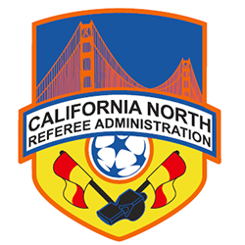
District Referee Administrators
Duties and Responsibilities

- Referee Registration
  - Process Renewals, Transfers, and Upgrades
  - Troubleshoot Registration issues
- Coordinate the activities of the DDI and DDA, including:
  - Sponsoring Refresher and Upgrade Clinics
  - Sponsoring Fitness Tests and Written Exams
  - Keeping accurate financial and administrative records
- Coordinate Requests for Upgrades with DDA and DDI to assure that the upgrade requirements have been met
- Maintain an accurate list of currently registered referees—share list with the DDA, DDI and Registered Assignors
- Maintain a “Personnel File” on each Grade 7, 6, and 5 Referee including
  - Assessments, D & Gs, praise/complaints, recommendations
- Maintain a List of the Top 10 Active Referees in the District
- Maintain a List of the Top 10 Up & Coming Referees in the District
- Act as Liaison to local Clubs, Referee Associations and District Commissioners
- Represent the interests of the District’s referees at the Protests and Discipline (PAD) Committee for the District, including:
  - Youth PAD hearings or meetings, including league or tournament play
  - Amateur PAD hearings or meetings, including league or tournament play
- Be available to attend State Referee Committee meetings as may be necessary

